Customer usernames are displayed publicly.

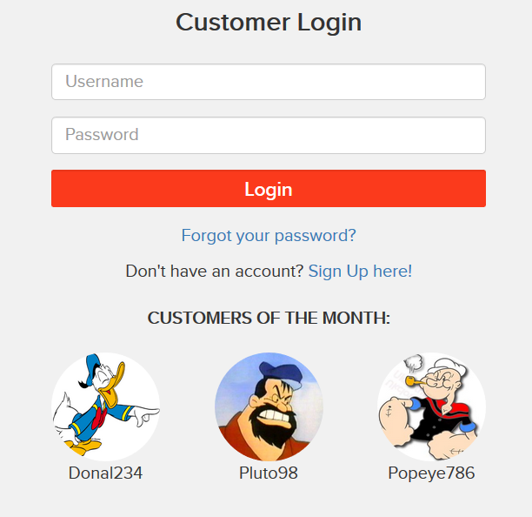

These can be compromised using the reset password feature.

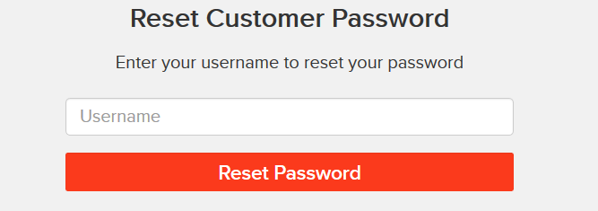

Seller personal details are visible when clicked on “seller info”.

